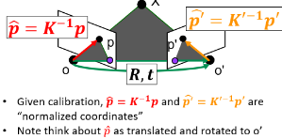
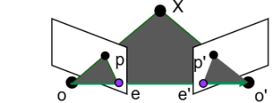
Epipolar Geometry
- Point X projects to p and p’
- The plane formed by X, o, and o’ is the epipolar plane.
- Epipoles e, e’ are where the baseline intersects the image planes.
- Epipole is the projection of other camera origin in the image plane; focus of expansion / optical center of the camera.
- Epipolar Lines go between the epipoles and projections of the points; out from the optical center.
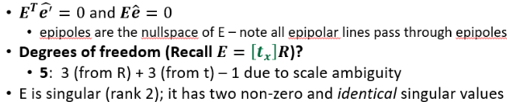
- Epipoles are finite, maybe in image; epipolar lines converge. Epipolar lines come in pairs.
Essential Matrix

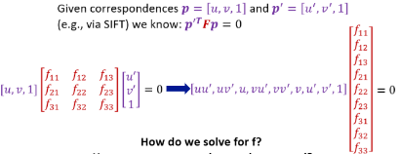
Fundamental Matrix
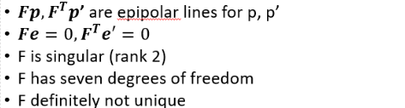
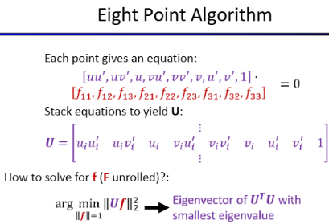
Eight Point Algorithm
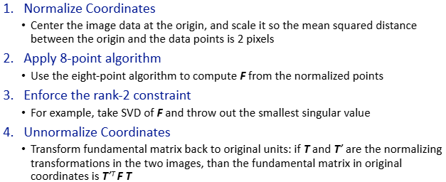
Normalized 8-Point

Stereo
- Stereo: given two calibrated cameras in different views and correspondences, can solve for X
- Cues: shading, texture, perspective effects, motion, familiar objects
- Calibration: figure out intrinsics of camera (to determine light rays)
- Motion: Figure out R, t for a set of cameras given correspondences
- Recovering Structure: Figure out 3D structure given cameras and correspondences
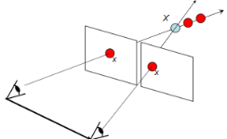
- Stereo/Epipolar Geometry: Figure out world coordinate for known point given 2 cameras and correspondence
Perspective Model
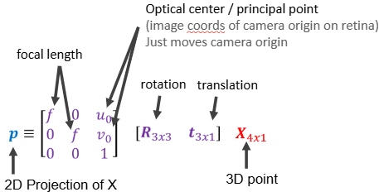
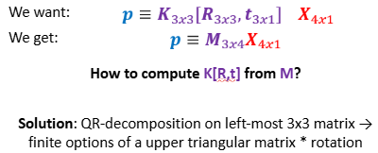
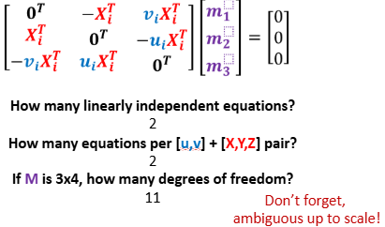
Camera Calibration

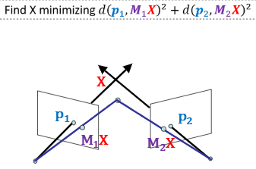
Triangulation (2 Options)
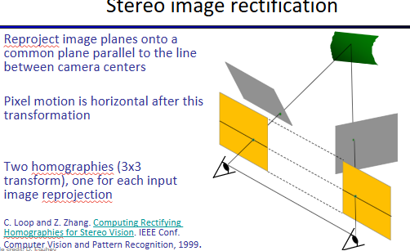
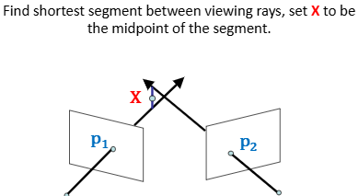
Depth from Stereo
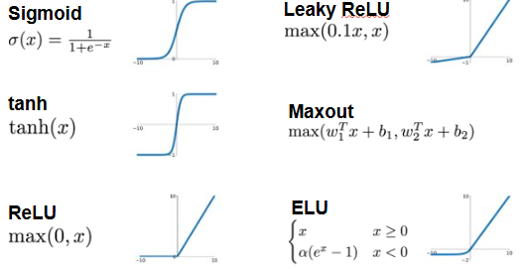
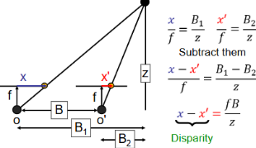
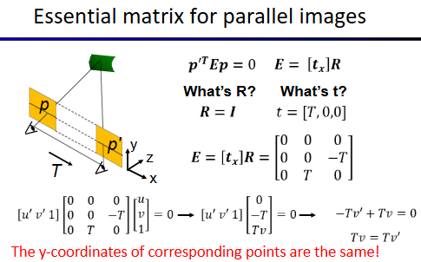
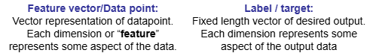
Machine Learning
Input: x Output: y
Supervised: given y Unsupervised: not given y – make our own

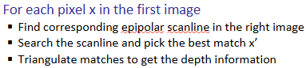
Classification / Categorization: bin into k categs (discrete / sup)
Regression: estimate continuous vars (continuous / sup)
Clustering: given sample, discover clusters/categs (discrete / unsup)
Dim Reduction: find dims to explain input (continuous / unsup)
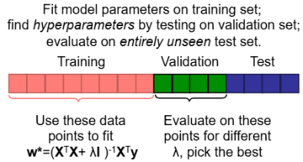
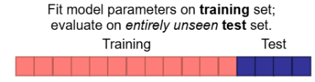
Training and Testing:
Nearest Neighbor
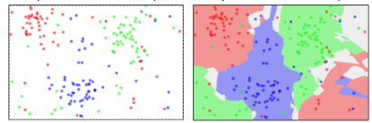
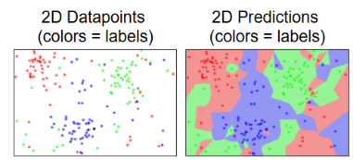
K-Nearest Neighbor
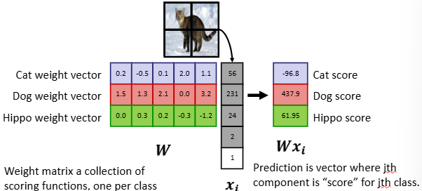
Linear Models
- If w_i is big, then big values of x_i
indicate class

Optimization
Grid Search: simple, but
scales horribly s^n
Random Search: simple,
but slow and may miss

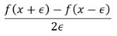
Gradient Descent: at each step, move in the direction of negative gradient. Compute the derivative.
Subgradient: any underestimate of a function (used for abs value, etc)
Step Size / Learning Rate: too small (falls short), too big (diverges). Momentum: exponentially decaying weights so LR gets smaller (solves issue of oscillation).
Multiple Minima: Gradient Decent finds local minimum. For convex functions, the local minimum is the global minimum.
Fitting
Underfitting: model doesn’t have parameters to fit the data
Overfitting: high variance; remove one point, model changes majorly
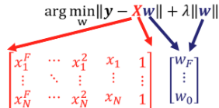
Big weights = more complex model
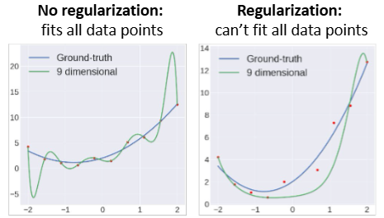
Regularization:

Bias: model is oversimplified. Variance: limited data
Inherent: difficult data
Bias v. Variance trade-off

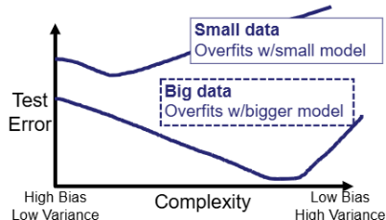
Underfitting: poor on training and validation due to bias. More features. More powerful model. Less reg.
Overfitting: well on training but poor on validation due to variance. More data. Less powerful model. Reg more.

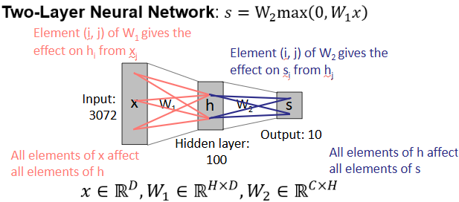
Neural Networks
Activation Function: Output of neuron based on inputs

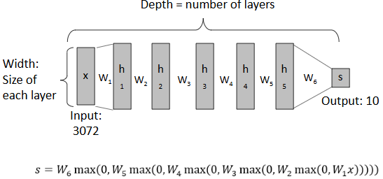

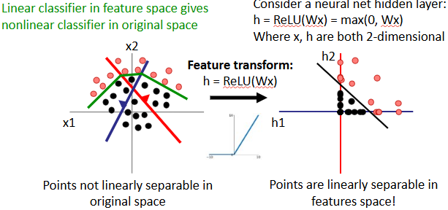
Space Warping

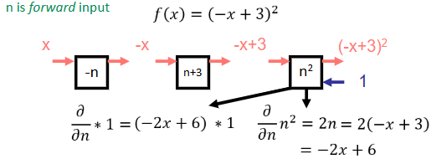
Backprop
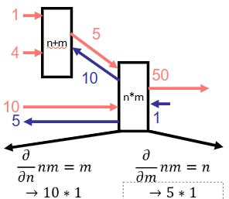
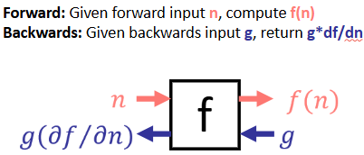
Given two inputs, have two inputs/output wires:
Forward: the same
Backward: the same – send gradients with respect to each variable

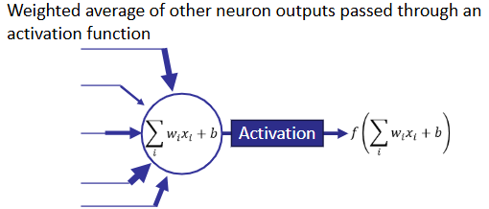
Artifical Neuron:
Connect neurons to make a more complex function; use backprop to compute gradient

Activation Function
Sigmoid: nice interpretation; squashes to (0,1); gradient near 0 if lo/hi
ReLU: constant gradient; conv 6x faster; if neg, then 0 gradient
Leaky ReLU: ReLU but allows small gradients for neg values
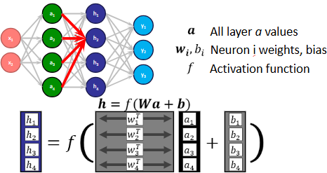
Fully Connected Network: each neuron connects to each neuron in previous layer

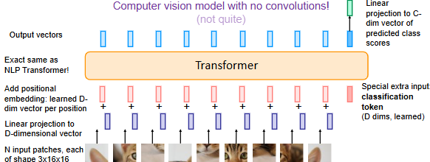
Parameters:
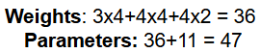
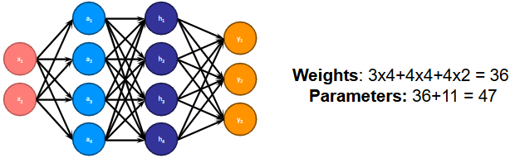

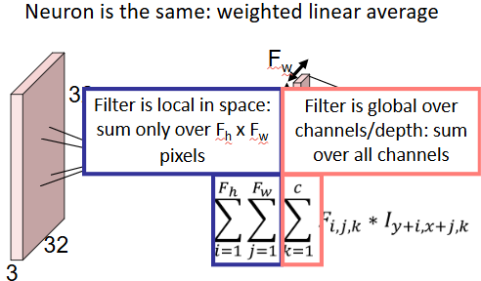
Convolutional Neural Network (Convnet)
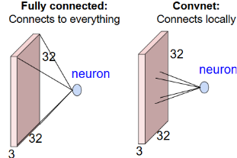
Get spatial output by sliding filter over image.
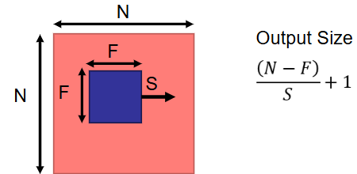
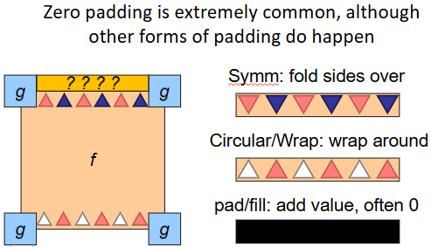
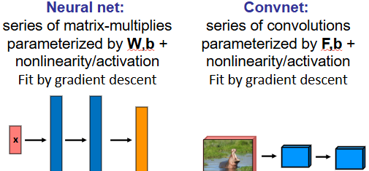
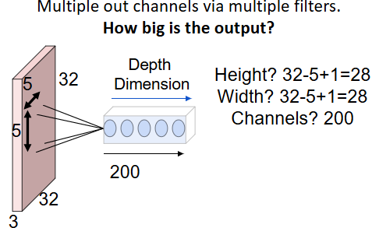

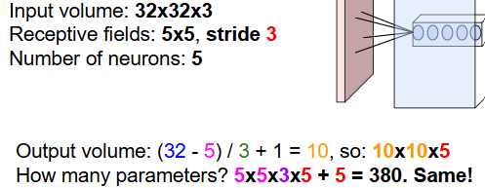

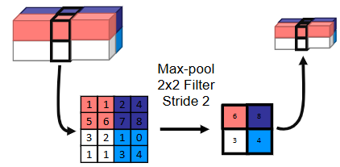
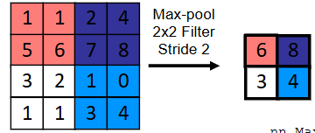
Pooling: spatial resolution of activations / image smaller; applied per-channel

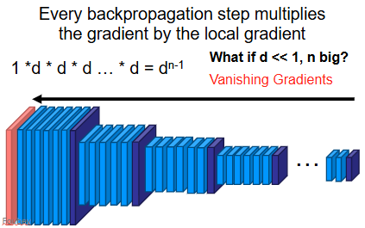
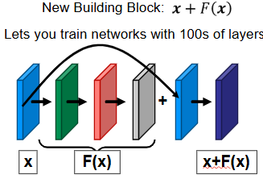
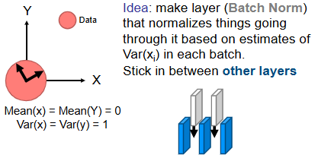
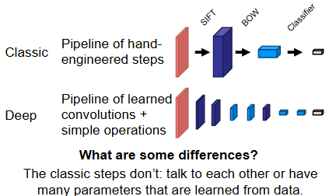
d >> 1 exploding gradient
Data Augmentation: apply transformations that do not effect the output
Fine Tuning: (1) extract some layer from existing network, (2) use as new feature, and (3) learn a linear model. OR Transfer learning (steal)
<10k img: features; always try finetuning; >100k img (scratch)
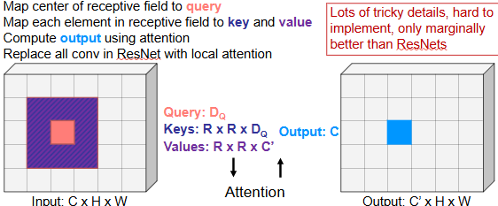
Self-Attention: enables referencing across long sequences
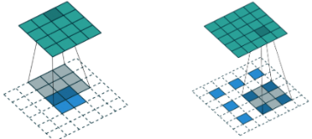
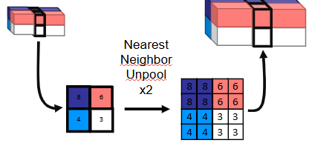
Unpooling Transpose Convolution

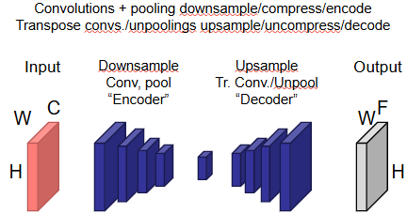
Encode to spatially smaller tensor, then decode. Encode to 1D vector, then decode.
R-CNN: accurate, modular; slow, ad-hoc training objectives
Fast R-CNN: region proposals + Rol polling on top of a conv feature
Faster R-CNN: RPN + Rol polling

